CAS PY 106

Prelecture Note 26

1. Understanding Maxwell’s equations
2. 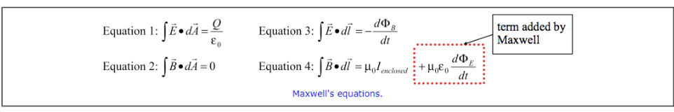
3. Equation 1 is known as Gauss’ Law for electric fields. It tells us that electric fields are produced by charges.
4. Equation 2 tells us that magnetic field lines are continuous loops
5. Equation 3 is Faraday’s Law in disguise, telling us that electric fields can be generated by a magnetic flux that changes with time
6. Equation 4 tells us that magnetic fields are produced by currents.
7. The equations told us that there were two ways to create electric fields (from charges, or from changing magnetic flux) but they only had one way to create magnetic fields (from currents)
8. One of Maxwell’s major contributions, then, was to bring in the second term on the right in equation 4, giving a second way to generate magnetic fields, by electric flux that changed with time, making the equations much more symmetric
9. Maxwell discovered the equations:

* E(x,t) = E0\*cos(wt-kx)
* B(x,t) = B0\*cos(wt-kx)

1. Maxwell derived an equation for speed of traveling electric and magnetic waves:

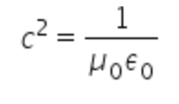

1. Maxwell proposed that light consists of oscillating electric and magnetic fields in what is known as an electromagnetic wave (EM wave)
2. Electromagnetic Waves
3. Electromagnetic waves are produced by accelerating charged particles
4. Visible light, for instance, can be produced by electrons changing energy levels inside atoms
5. Radio waves are produced by connecting a source of oscillating voltage to one or more metal rods (antennas), causing elecgrons to oscillate back and forth along the rod
6. The charge separation is associated with the production of electric fields, while current associated with the moving electrons generates the magnetic fields
7. Properties of electromagnetic waves
8. 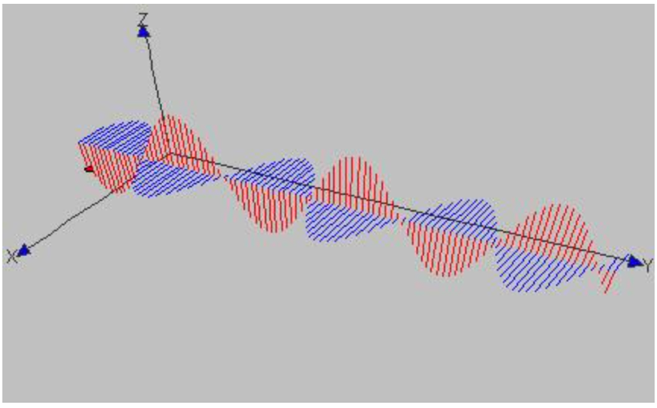
9. Some general features of electromagnetic waves include:
10. Energy carried by electromagnetic wave is divided equally between electric fields and magnetic fields
11. Electric and magnetic fields are in phase with one another
12. Both electric field vectors and magnetic field vectors are perpendicular to the direction of propagation of the wave. EM is classified as transverse wave
13. The direction of propagation can be determined by applying thhe right-hand rule. Start with your fingers on your right hand pointing in direction of electric field at a particular point on the wave. If you align your hand so that you can curl your fingers from the electric field direction to the magnetic field direction, your thumb, sticking out, will point in the propagation direction of wave
14. At all points on the wave, the ratio of electric field and magnetic field is given by

C = E/B

1. Radiation pressure
2. All waves carry energy, and electromagnetic waves are no exception
3. Average intensity of electromagnetic wave is

I = average power/area = Emax\*Bmax / (2\*u)

1. Momentum and radiation pressure
2. There is no mass associated with light but electromagnetic wave carries momentum
3. Radiation pressure when a wave reflects 100%: P = 2I/c
4. Radiation pressure when a wave is 100% absorbed: P = I/c
5. Designing a solar sailboat
6. Design a solar sailboat to explore solar system
7. Data given:
8. Mass of sun M:: 2\* 10^30kg
9. Mass of the solar sailboat: m = 1000kg
10. Power emitted by Sun in form of electromagnetic waves: p = 4 \* 10^26W
11. Steps
12. Find an expression for the gravitational force exerted on the satellite by the Sun, if the satellite is a distance r from the Sun

Fg = GmM/r^2 where G = 6.67\*10^-11

1. Find expression for intensity of sunlight reaching the spacecraft

I = power/4pi/r^2

1. Assuming the sail deployed by the spacecraft is perfectly reflective, find an expression for the force exerted on the sail by the reflecting sunlight. Assume also that the sails are oriented to reflect the sunlight straight back toward the Sun

Frad = P\*A (P is the radiation pressure and A is the sail area)

Frad = 2I/c \* A = 2 \* power \* A / (c \* 4pi\*r^2) = A \* power / (c\*2pi\*r^2)

1. Determine sail area required to balance the gravitational force exerted on the spacecraft by the Sun:

GmM/r^2 = A\*power/(2pi\*r^2\*c)

A = 2pi\*c\*G\*m\*M/power

1. Doppler effect for EM waves
2. Doppler effect for EM waves is imply relative-velocity phenomenon
3. If the source emits EM waves that have a frequency f, the observed frequency f’ is given by

f’ = f (1+- v/c) where v is the magnitude of relative velocity between source and observer

1. + sign is when the source and observer are moving toward one another
2. – sign is when the source and observer are moving farther apart
3. To catch a speeder
4. Another application of Doppler effect is Doppler radar, used in weather forecasting
5. Ex: a police officer in stationary police car aims a radar gun at a truck traveling directly toward the police car. The frequency of the radar gun is 10.525GHz (10.525\*10^9 Hz) and the frequency of waves reflecting from the truck and returning to the radar gun is shifted from the emitted by frequency by 1600Hz. If the speed limit on the road is 60km/h, should the officer pull the truck over to give the driver a ticket?
6. Step 1: is frequency of waves coming back to the radar gun higher or lower than the frequency of the emitted waves?

The relative velocity of the two vehicles brings them closer, which effectively lowers the wavelength of the waves, corresponding to a higher frequency

1. Step 2: If the truck is traveling at a speed v, write an expression for f’, the frequency of the waves received by the truck

We use the Doppler effect:

f’ = f(1+v/c).

We use plus sign since the truck is moving toward the police car

1. Step 3: Write an expression for f’’, the frequency of the waves that are picked up by the radar gun after reflecting from the truck. Your expression should be in terms of f, rather than f’.

We use the Doppler effect again.

f’’ = f’(1+v/c) = f (1+v/c)^2

Again, we use the plus sign since the truck is moving toward the police car

1. Step 4: Solve for speed of truck and decide whether the truck driver should get a speeding ticket

f’’ = f(1+v/c)^2

f’’ = f(1+2v/c+v^2/c^2)

v^2/c^2 can be neglected since v^2/c^2 is much smaller than v/c

f’’ = f(1+2v/c) = f + 2fv/c

f’’-f = 2fv/c

1600 = 2fv/c

v = 1600\*c/2f = 1600\*3\*10^8/2/(10.525\*10^9) = 22.8 m/s

22.8m/s is 82km/h, which is over the speed limit, so driver should certainly get a speeding ticket.